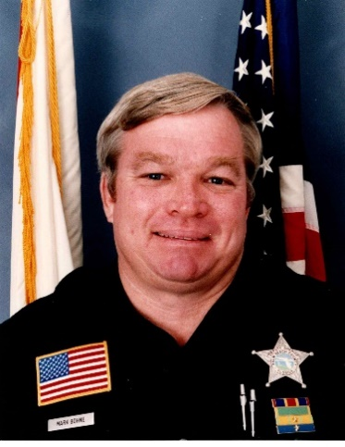
Mark C. Bohne began his career with the Riviera Beach Police Department in 1974. Three weeks into his service, his field training officer was killed in the line of duty. For many, this would be career ending; however, Sergeant Bohne continued and joined the Palm Beach County Sheriff's Office (PBSO) in 1983. In 1986, he was confronted by an armed suspect and sustained five gunshot wounds. Sergeant Bohne pursued the suspect until he realized the extent of his injuries. During his recovery, dairy farmer Billy Bowman offered to assist with his finances. Approximately one year later another PBSO Deputy was seriously injured in the line of duty, and Mark and Billy did a fundraiser for that officer. They went on to create a nonprofit charity called the Law Enforcement Assistance Foundation (LEAF). Its primary mission is to provide financial assistance to law enforcement officers who are seriously injured or have suffered a catastrophic event as well as to support the families of officers killed in the line of duty. Since its inception, LEAF has distributed over $1 million to the families of fellow law enforcement officers. In 2009, Sergeant Bohne was recognized as the Palm Beach County “Community Leader of the Year.” He proudly served with PBSO until 2010. During his service, he received numerous accolades including many PBSO Officer of the Month awards. Sergeant Bohne’s lifetime dedication and determination of selfless service towards his county and fellow officers demonstrates the hallmarks of a true law enforcement professional.

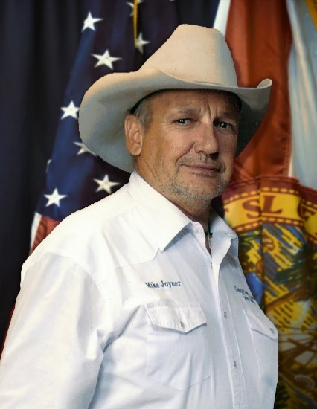
Michael F. Joyner began his law enforcement career with the Monticello Police Department in August of 1973. In January of 1974, he was hired by the Jefferson County Sheriff’s Office. During his 12 years working for Jefferson County, Joyner saved the lives of four individuals in three separate incidents. In 1986, Citrus County Sheriff Charlie Dean hired Joyner to work in a long-term undercover operation that lasted 18 months. The intense operation infiltrated three drug smuggling rings and uncovered a mafia-owned nightclub in Citrus County. The operation resulted in 72 indictments and convictions. At the conclusion of that operation, Joyner was awarded the Medal of Distinction. Undersheriff Joyner was an incredibly talented undercover officer. While working undercover, he was placed in prisons and jails in multiple states, and he played a major role in solving several homicides. His most notable undercover case was the capture and conviction of notorious female serial killer, Aileen Wuornos. Wuornos was a nationally known murderer who was convicted of killing seven people in Florida between 1989 and 1990. In 2005, Joyner retired with 32 years of dedicated service. Throughout his career, Undersheriff Joyner received numerous awards, and is one of only four lifetime members of the Florida Intelligence Unit. In 1993, he received the Narcotics Officer of the Year award. He has received several commendations from the United States Drug Enforcement Administration, the United States Marshall Service, and the United States Customs Service. In 2018, the Florida Intelligence Unit created the Mike Joyner Law Enforcement Officer of the Year award which recognizes an officer’s contributions and outstanding service.

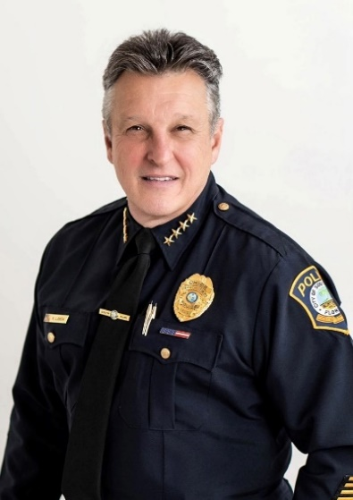
René G. Landa began as a patrol officer for the Miami Police Department in 1980 serving with them for 25 years. In total, he served the residents of South Florida for 43 years as an officer in three different police departments. His unselfish dedication as a crime fighter and law enforcement leader is well known, and his legacy includes contributions to the advancement of the law enforcement field. During his service, he risked his life working as an undercover narcotics detective and SWAT officer amid the cocaine wars of the 1980s and 1990s. He also worked with the Special Investigations section, Street Narcotics unit, Special Events, Sexual Battery unit, Planning and Research, Emergency Planner, and Terrorism Task Force. He rose through the ranks to become one of the commanders for the City of Miami Police Department’s elite SWAT team. In 2005, Chief Landa joined the Key Biscayne Police Department as a major and, within two years, was promoted to division chief. In 2010, he joined the South Miami Police Department as a major and was promoted to chief of police in 2014. In 2014, under the watch of Chief Landa, the South Miami Police Department (SMPD) received initial accreditation status by the Commission on Florida Law Enforcement Accreditation. Chief Landa led the charge and set the tone for the SMPD during the COVID-19 pandemic and during the “Defund the Police” movement. Chief Landa became concerned with officer morale and ensured that all the officers stayed positive. In May of 2021, Chief Landa became the president of the Miami Dade County Association of Chiefs of Police (MDCACP). Based on what he learned from the pandemic and the anti-police movement, he aimed to create an entity that could assist smaller departments with mental wellness for law enforcement’s number one asset—its personnel. Chief Landa’s leadership over the years has made a great impact in the community; he puts others before himself and is always looking for ways to better law enforcement agencies, especially in the field of officer wellness.
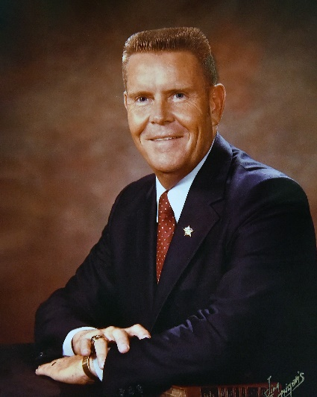
Don R. Moreland began serving his community in 1952 when he enlisted in the United States Navy and served his nation until 1956. He began his law enforcement career immediately upon his return in 1956 with the Ocala Police Department. In 1957, he joined the Marion County Sheriff’s Office and worked his way through the ranks before his election as Sheriff of Marion County in 1972 where he served five consecutive terms. In 1993, President Bill Clinton appointed Sheriff Moreland as the United States Marshall for the Middle District of Florida where he remained until his retirement in 2003. As sheriff, he demonstrated unsurpassed management and leadership skills that were directly responsible for the implementation of numerous programs and policies that moved the sheriff’s office into the modern era of law enforcement. Sheriff Moreland has received the Distinguished Service Award for Law Enforcement, graduated from the FBI National Academy, and was appointed by Governor Askew to the Governor’s Commission on Criminal Justice Standards and Goals and the Criminal Justice Information System’s Council. He has also served as president of the Florida Sheriffs Association and was chairman on their board of directors. He has been an invaluable asset to Marion County and the state of Florida, all of which he served with honor and distinction.
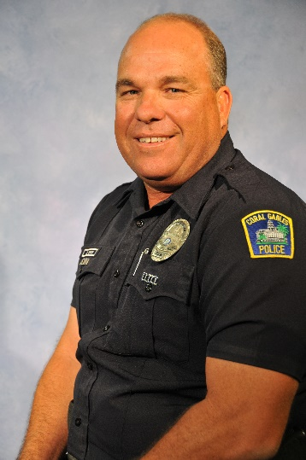
Daniel A. Smith began his law enforcement career as an officer in 1990 with the Florida Highway Patrol (FHP). As a trooper, his commitment to public safety was exemplified. He earned recognition as a top DUI trooper in Florida with over 200 DUI arrests in three consecutive years. After joining the Coral Gables Police Department in 1996, Officer Smith continued to display professionalism, courage, and dedication. He has been called a cornerstone of the department, and his fellow officers have said that his retirement has left an irreplaceable void. Officer Smith’s commitment to justice is evident in his extensive record of investigating and documenting over 2,000 cases involving DUI crashes and trials. The lives saved due to his diligence and expertise cannot be quantified, and the families spared from the anguish of losing a loved one due to his efforts are a testament to his immeasurable impact. Tragically, Officer Smith knows the heartache of losing a family member to drunk drivers firsthand; his brother, Trooper Robert Smith, was killed by a drunk driver in 1997. In 2014, Officer Smith received the Robert DeKorte Memorial Award, which is the highest accolade bestowed upon an officer in the City of Coral Gables. Officer Daniel Smith embodies the qualities that this award represents—courage, dedication, and devotion to duty. He served as a field training officer for over 23 years, which allowed him to provide hands-on training to a significant portion of the Coral Gables Police Department. An officer who once worked with Danny said that “[Officer Smith] can be counted on to teach, mentor, and evaluate at the highest standard.” He is always there for others and sacrifices himself to better those around him. His dedication to public safety, mentorship, and community service embodies the highest standards of the profession and leaves a lasting legacy that will continue to inspire generations to come.

